**SPRINT-I**

SETTING UP THE APPLICATION ENVIRONMENT

Install IBM Cloud CLI:

There are some tutorials in the dashboard here after creating an account in the IBM cloud. We will install the IBM cloud CLI utilizing the get started with CLI guide that will show up in that.

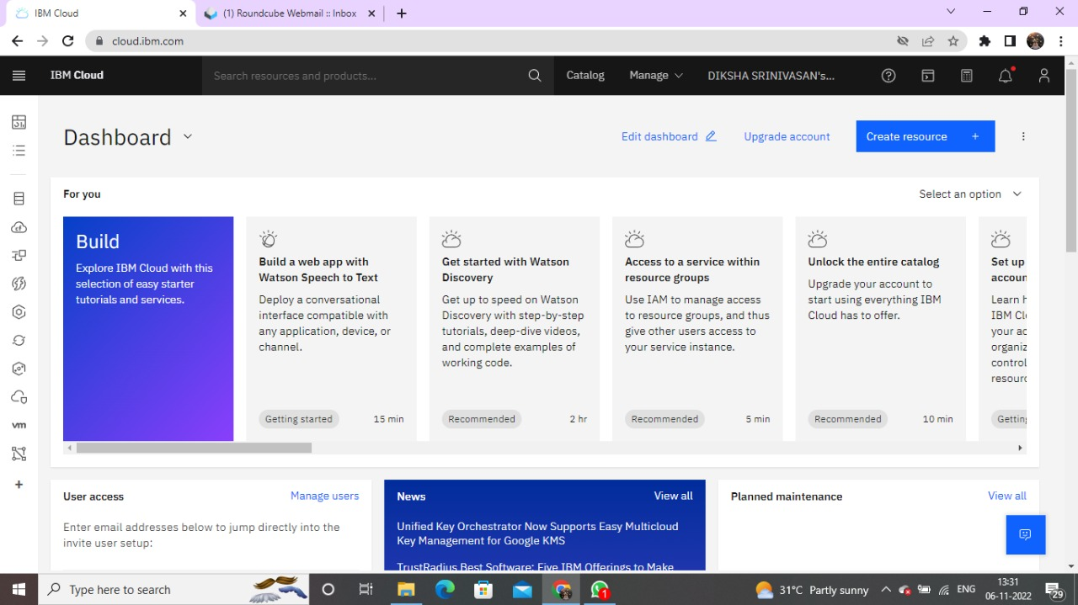

When you click on that tutorial, a page with instructions for installing IBM cloud CLI and some plugin tools with the CLI for work purposes when creating and deploying the Application will open.

Use the following Command to Install the IBM Cloud CLI:

iex (New-

ObjectNet.WebClient).DownloadString('[https://clis.cloud.ibm .com/install/powershell'](https://clis.cloud.ibm.com/install/powershell))

After Installed IBM cloud CLI the PowerShell screenshot shown below:

